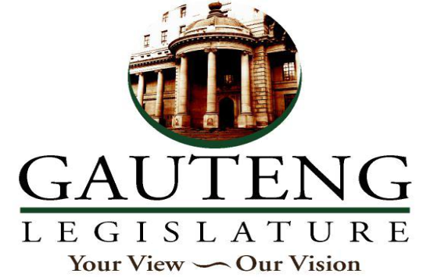

**ECONOMIC DEVELOPMENT PORTFOLIO COMMITTEE**

**9th FRIDAY, JUNE 2023**

**SAUL TSOTETSI COMMUNITY HALL, SEBOKENG UNIT 14**

**STAKEHOLDER ENGAGEMENT SESSION WITH THE DEPARTMENT OF ECONOMIC DEVELOPMENT**

|  |  |  |
| --- | --- | --- |
| **ITEM** | **DELEGATED TO** | **DURATION** |
| **Opening, welcome, purpose of the meeting** | **Hon. Chairperson William Matsheke** | **11H00 – 11H10** |
| Presentation by the Department of Economic Development on   * the Vaal SEZ’s development – status, budgets, number of people employment at the PMO/PMU, investment, and turnaround times. | **Hon. MEC Motara and Departmental Officials** | 11H10 – 11H40 |
| Questions and Answers | All | 11H40 - 12H15 |
| Presentations by the Department of Economic Development   * The Gauteng Tourism Agency to also make presentations on the destination marketing of all tourist attractions in the Sedibeng Region. | **Hon. MEC Motara and Departmental Officials** | 12H15- 12H45 |
| Questions and Answers | **All** | 12H45-13H15 |
| Presentations by the Department of Economic Development   * A detailed presentation on challenges and success of the work undertaken by the Gauteng Enterprise Propellor in the Sedibeng Region. This should highlight the support offered to SMME’s in the region. | **Hon. MEC Motara and Departmental Officials** | 13H15- 13H45 |
| Questions and Answers | **All** | 13H45- 14H15 |
| **Closure and way forward** | **Hon. Chairperson William Matsheke** | **14H15** |
|  | | |