No.220 - 2022: Fourth Session, Sixth Legislature

GAUTENG PROVINCIAL LEGISLATURE

========================

ANNOUNCEMENTS,
TABLINGS AND
COMMITTEE REPORTS

========================

Monday, 20 June 2022

ANNOUNCEMENTS
none

TABLINGS
none

COMMITTEE REPORTS
1. The Chairperson of the Community Safety Portfolio Committee, Hon. A A Ndlovana, tabled the Committee’s Focused Intervention Study (FIS) Report on Assessing the Implementation and Effectiveness of Road Safety Plans to Reduce Road Crashes and Fatalities in Gauteng for the 2021/22 FY, as attached.

Community Safety Committee Focused Intervention Study (FIS) Report on Assessing the Implementation and Effectiveness of Road Safety Plans to Reduce Road Crashes and Fatalities in Gauteng for the 2021/22 FY

Committee Details |  |  | Department Details
Name of Committee | Community Safety Portfolio Committee |  | Name of Department | Department of Community Safety
Financial Year | 2020/21 FY |  | Dept. Budget Vote Nr. | Vote 10
 |  |  | MEC | Hon. Faith Mazibuko
Committee Approvals
 | Name | Signed |  |  | Date
Hon. Chairperson | Hon. Alphina Ndlovana |  |  |  | 15th June 2022
Adoption and Tabling
Date of Final Adoption by Committee  15th June 2022 |  | Scheduled date of House Tabling  21st June 2022

Contents
1. EXECUTIVE SUMMARY 4
2. INTRODUCTION 5
3. PROCESS FOLLOWED 5
4. COMPLIANCE AND QUALITY 6
5. OVERSIGHT ON STRATEGIC PRIORITIES 6
5.1. Priorities 6
6. COMMITTEE FOCUS AREA 6
7. PERFORMANCE VERIFICATION 10
8. COMMITTEE FINDINGS AND OBSERVATIONS 11
9. COMMITTEE CONCERNS 13
10. COMMITTEE RECOMMENDATIONS 13
11. ACKNOWLEDGEMENTS 14
12. ADOPTION 14

ABBREVIATIONS
Abbreviation | Full Wording
AARTO | Administrative Adjudication of Road Traffic Offences
COVAC | Committees Oversight and Accountability framework
CSCs | Client Service Centres
EMPD | Ekurhuleni Metro Police Department
FIS | Focused Intervention Study
HOD | Head of Department
LAEs | Law Enforcement Agencies
MEC | Member of Executive Council
MOU | Memorandum of Understanding
MPDs | Metro Police Departments
NGOs | Non-Government Organisation
RAR | Receive, Assess, and Refer model
RTMC | Road Traffic Management Corporation
SANRAL | South African National Roads Agency
SAPS | South African Police Service
SOM | Sector Oversight Model

COMMUNITY SAFETY PORTFOLIO COMMITTEE

21 June 2022,

The Chairperson of Community Safety Portfolio Committee, Hon. Alphina Ndlovana tables the Committee Focused Intervention Study (FIS) Report on “Assessing the Implementation and Effectiveness of Road Safety Plans to Reduce Road Crashes and Fatalities in Gauteng for the 2021/22 FY”, as follows:

EXECUTIVE SUMMARY

This Focused Intervention Study (FIS) emerged from the constant surge of road crashes and fatalities in the province. Through the study, the Committee aimed to assess the implementation and effectiveness of road safety plans by the Gauteng Department of Community Safety.

The Department has a constitutional mandate to ensure that all citizens in the province are and feel safe. It is through the Traffic Management programme where the Department develops and implements intervention programmes to ensure attainment of its road safety targets. During the period 2011 – 2020, the Department planned to achieve at least 50% reduction on road crashes and fatalities.

Gauteng is dubbed the economic hub of South Africa; thus, it has the largest human population of more than 15.2 million people, with vehicle population estimated at 4.9 million. The Committee noted the report that an average of 7 road users are killed per day in Gauteng.

The province recorded at least 9,730 fatalities from 8,741 fatal road crashes in the past 4 years, from 2018 – 2021. In 2020 there were 1,949 fatalities despite the country being on lockdown; and these incidents increased to 2,610 in 2021, marking an increase by 34% when compared to the 2020 period.

In terms of the various categories, there were 904 pedestrian fatalities in 2020 and increased to 1270 in 2021, marking 48.7% increase, 489 driver fatalities were recorded in 2020 and in 2021 they increased to 635 (24.3%), 417 passengers succumbed to fatal crashes in 2020 with 498 passenger deaths in 2021 (18.9%), motorcycles accident recorded 89 incidents in 2020 and 120 in 2021 (4.6%), whilst cyclist recorded 39 and 61 in 2020 and 2021 respectively, marking an increase by (2.3%).

The Committee noted at number of factors which contributes to the upsurge in tragic crashes and fatalities. These include poor road environment, unroadworthy vehicles, road user behaviour which include reckless and negligent driving, driving while under the influence of alcohol, speeding, overloading, using a cellphone while driving, failing to wear seatbelts, to mention a few.

The Committee further noted that one of the major disturbing elements emerging from the study is the vulnerability of pedestrians. Pedestrians account for nearly half of the road fatalities in the province, making them the most vulnerable group.

The Committee is concerned that despite various intervention programmes being implemented aimed at traffic law enforcement and improved road safety, the reduction target was never achieved, and fatalities continued to increase.
The Committee believes that to achieve a significant reduction on road fatalities, emphasis must be put on regular maintenance of poor road environment and changing human behaviour.

INTRODUCTION

This FIS emanates from the Committee’s assessment of the Department of Community Safety’s budget report of the 2021/22 financial year. The FIS was focused on assessing the implementation and effectiveness of Road Safety Plans to reduce road crashes and fatalities in the Gauteng Province.

The Department of Community Safety has a dedicated programme promote road safety and which focuses on traffic law enforcement. The programme intended to curb the scourge of road rashes and fatalities in the province. It aims to integrate and coordinate traffic law enforcement through data-driven initiatives to reduce road fatalities. The programme is also in charge of improving road user knowledge, skills, attitudes in road safety.

There are four sub-programmes, namely Traffic Law Enforcement, Special Services, Public Transport Inspectorate and Road Safety Promotion within the main programme. Road Safety Promotion sub-programme is mainly focused on creating awareness and promoting safety on the roads with the aim of reducing road fatalities.

The Traffic Management Programme takes up the biggest share allocation of the Department’s appropriation. The programme received R560 million in the 2021/22 financial year, which was distributed amongst its various sub-programmes. The Public Transport Inspection sub-programmes received the largest allocation of R314 million, followed by the Traffic management with an allocation of R188 million, whilst Special Services and Road Safety Promotion and received R35.5 million and R20 million respectively.

A Decade of Action for Road Safety was declared for the period 2011-2020. Subsequently, South African set a target to reduce road fatalities by 50% by 2020. This saw the Gauteng Department of Community Safety setting a reduction target of 10% annually. Therefore, this report will focus on assessing the department’s performance in achieving its target.

PROCESS FOLLOWED

4.1 The Committee considered and deliberated on the concept document of the FIS topic “Assessing the implementation and effectiveness of Road Safety Plans to reduce road crashes and fatalities in the Gauteng Province” through a virtual meeting held on the 03rd of February 2022. The concept document provided a detailed analysis including the objectives of the study.

4.2 The Committee conducted two stakeholder engagement sessions. The first session was on 04 March 2022 at Mafatsane Community Hall in Evaton, Sedibeng Region. The second session was held on 27 May 2022 at Laudium Community Centre in Tshwane Region.

4.3 The Committee consider and adopt its FIS report at a virtual meeting held on 15th June 2022.

COMPLIANCE AND QUALITY

The assessment was conducted in accordance with the SOM and the Standing Rules of the Gauteng Provincial Legislature. The report also followed the guidelines of the COVAC format of reporting adopted by the Gauteng Provincial Legislature.

OVERSIGHT ON STRATEGIC PRIORITIES

Priorities

The Department’s mandate is aligned to achieve its outcome, that is, “All people are and feel safe”. Its provincial priorities are reduction in priority crimes, reduction in crimes against women and children, social crime prevention and crime perception management.

This study was focused on the objectives of the Traffic Management Programme. The Programme is aimed at integrating and coordinating traffic law enforcement through data driven projects to reduce road fatalities. Through the programme, the Department responds to reported road accidents and support the South African Police Service (SAPS) on crime prevention and combating initiative. It is also responsible for enhancement of road user knowledge, skills attitudes, and pedestrian safety.

5.2 Objectives of the study
The study was aimed at:
- Assessing road safety promotion programmes and their shortcomings.
- Examining whether the safety promotion programmes are effective in reducing road crashes and fatalities.
- Assessing plans in place and their progress in addressing contributing factors in road crashes and fatalities.
- Make recommendations to reduce road crashes and fatalities, thus, improve road safety.

COMMITTEE FOCUS AREA
6.1 Presentation by the Department of Community Safety

The Department has a constitutional mandate to ensure that all citizens in the province are and feel safe. In the context of this study focus was assessing the performance of the Department in ensuring road safety.

The Department reported that the Traffic Management programme draws its existences from the National Road Safety Strategy 2016 – 2030, the Second Decade of Action for Road Safety 2021 – 2030 and the Performance agreement of the MEC of Community Safety 2019- 2024. It further subscribes to five pillars of the Vision 2055 related to traffic management which are: Improve Police Visibility; A Safer Road Environment; Pedestrian Safety; Traffic Law Enforcement; and Institutional Arrangement.

Gauteng is regarded as the economic hub of South Africa; thus, it has the largest human population of more than 15.2 million people, with a vehicle population estimated at 4.9 million accounting for 38% of all registered motor vehicles.

The province recorded at least 9,730 fatalities from 8,741 Fatal Road Traffic Crashes in the past 4 years, from 2018 – 2021. It was reported that an average of 7 road users are killed per day in Gauteng. The table below depicts road fatalities for 2018 to 2021.
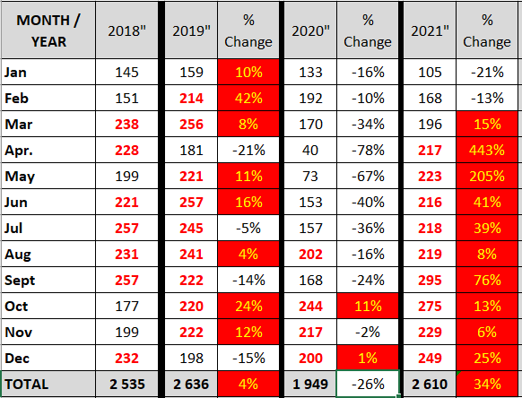

It can be noted from the table above that during the period March to September 2020 there was a significant reduction in fatalities. This was however because of the restrictions related to the State of Disaster which was declared in March 2020. As the lockdown restrictions were being relaxed road fatalities went up sharply.

The below table demonstrates the various categories of fatalities for the period 2018 – 2021.
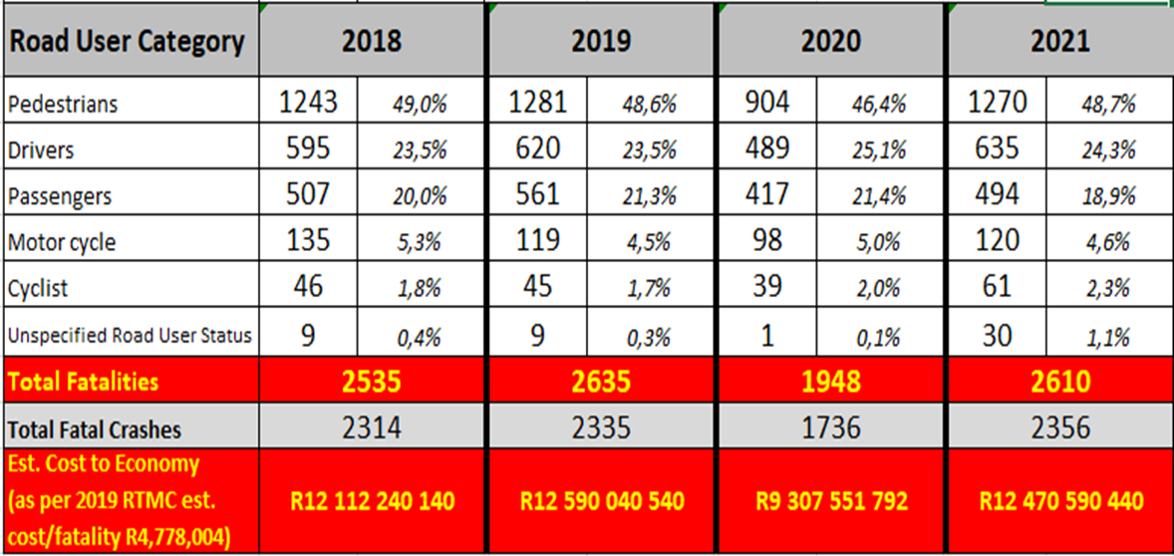

It was reported that pedestrians were the most vulnerable and highest contributor. Despite the significant reduction in fatalities during 2020, the percentage distribution per road user category remained consistent through the reporting period. Most fatal crashes were recorded during weekends, Friday afternoon to early Monday morning.

The below table provides an outlook on fatalities per category within the various municipalities for period 2018 – 2021.
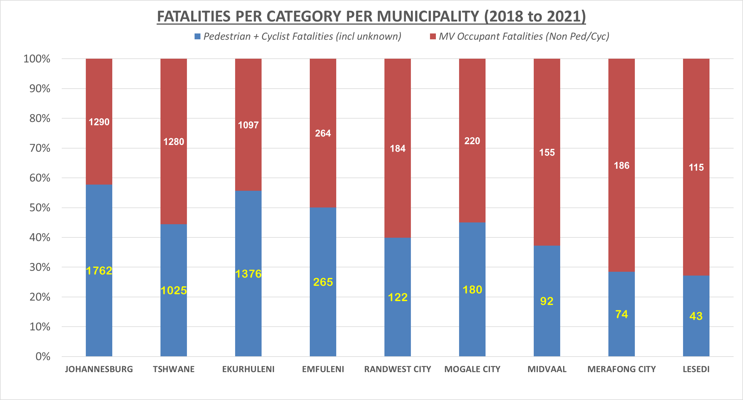
The Department reported that a 365-day integrated plan was develop amongst jointly with all the various law enforcement agencies and role-players in the community safety spectrum. The plan was focused on conducting law enforcement operations. The plan was categories into four key focus areas.

- High Density Operations: which included pedestrians, reckless and negligent driving, education, and enforcement of safety belts for passengers and child restraints, tyre checks, education on the effects of alcohol, drugs and substance abuse for drivers and pedestrians, fatigue, driver behaviour, speed enforcement, and educating refuse recyclers on proper use of the road.
- Critical period operations: referring to the easter period, long weekends, public holidays, youth month, woman’s month, heritage month and transport month, 16 days of no violence against women and children, festive season operations safety month
- Key Focus Areas: these are mainly operations focusing on; Traffic Law Enforcement, Crime Prevention, By-law Enforcement, Road Safety campaigns, Education at all learning institutions, Driver Education, Mass measuring (Overloading).
- Awareness campaigns: which are conducted to share road safety tips, promote voluntary compliance by road users, as well as communicating the consequences of unsafe behaviour to stimulate change in behaviour of motorists and pedestrians.

The Department reported that efforts were made to reduce fatalities however they were not without challenges such as fragmented traffic law enforcement operations and insufficient resources to enable a 24/7 deployment of traffic officers throughout the year. The Department’s Traffic Law Enforcement officers are employed within the basic conditions of employment agreement, with standard working hours. The Department was still gridlocked on a consultative process to have them classified an essential service.

The Department further reported outlined various risks which negatively impact on the effective law enforcement as follows:
- Bribery and corruption.
- Law enforcement authorities reporting to different political and operational command structures with varying priorities.
- Lack of 24/7/365 deployment from national, local, and provincial traffic due to budgets, resources and not being classified as essential services
- Lack of dedicated Traffic offence criminal investigation, prosecution, and traffic courts. This results to cases being withdrawn, rendering the operations and arrest fruitless.
- Land grabs / urbanization, residential and commercial development approvals without significant road safety infrastructure improvements e.g., pedestrian bridges, streetlights, etc.
- Vandalism of essential infrastructure such as Traffic lights and streetlights,
- Unsafe road environments, including potholes, lack of road markings, etc.
- Operations outputs not focused on priority offences, e.g., more fines issued for documentary offences compared to moving violations.
- Legal challenge to AARTO legislation.

PERFORMANCE VERIFICATION

As part of performance verification, the conducted two stakeholder engagement sessions to solicit inputs from the residents of Gauteng, which are the road users and most affected by the scourge of road fatalities. The stakeholder engagement sessions were held in Evaton in the Sedibeng region and Laudium which is under Tshwane region.

7.1 Stakeholders Submissions

The following inputs were submitted by stakeholders:
Law enforcement agencies were urged to enhance visible policing and intensify intervention measures to address spiking incidents on freeways particularly on R80 in Tshwane. The Ekurhuleni Metro Police Department (EMPD) confirmed the prevalence of spiking incidents and reported that it had intensified law enforcement operations jointly with other Law Enforcement Agencies (LAEs) to apprehend the culprits and curb these criminal acts.

Also, communities reported that motorists are forced to stop by throwing stones or eggs when passing under bridges with the intention to hijack them, this however results in road accidents.

Stakeholders expressed concerns regarding the high number of accidents within the Bronkhorstspruit Road which is dominated by trucks contracted by mines to transport coals. It was alleged that the trucks delay traffic which results in impatience by other motorists, thus, resorting to reckless driving such as unsafe overtaking.

Stakeholders reaffirmed the grim impact of poor road environment on road fatalities. It was requested that local municipalities must speedily address poor road conditions, ensure proper road signage, visible road markings, operational traffic lights etc. In addition, it was requested that municipalities must prioritize speed calming humps requests from communities to minimize speeding at residential areas, which often result in children being the most vulnerable group of hit-and-run accidents.

The Committee also noted the concern that when it rains potholes gets filled with water and motorists will unknowingly hit those potholes and cause an accident, such being caused by poor road maintenance which could have been avoided.

Stakeholders requested that scholar patrol initiatives be strengthened to improve the safety of learners. It was further requested that regular inspections be conducted in all transports contracted to ferry learners to and from schools, to check their roadworthiness and overloading, as well as vetting of service providers rendering transport services for leaners.

Whilst stakeholders conceded that there was insufficient provision of pedestrian bridges at freeways, it was also reported that the walls which were erected along freeways to limit crossing-over were being vandalized, and it seemed there was no interest from Law Enforcement Agencies to address such criminal actions.

Stakeholders supported the report by the Department regarding lack of integration amongst Law Enforcement Agencies (LAEs). It was proposed that LAEs must develop memorandum of understandings (MOUs) to ensure well-coordinated multidisciplinary approach in policing.

The number of accidents occurring at the notorious Moloto road were a concern. It was also alleged that PUTCO bus drivers were reckless, negligent, and often driving over speed limits and forcing other motorists off the road, exposing them to danger especially at Moloto road. The Department reported that traffic law enforcement operations were intensified. It was also reported that Moloto Road was now under the administration of the South African National Road Agency (SANRAL).

Moreover, stakeholders expressed concerns regarding the rife network of bribery and corruption involving driving school instructors and examiners at Driver Licence Testing Stations (DLTCs) soliciting bribes in exchange for leaners and driver’s licenses.

- COMMITTEE FINDINGS AND OBSERVATIONS

The Committee made observations and findings as detailed hereunder:

Insufficient recourses
The Committee noted the report that most motor vehicle fatalities were prevalent during weekends, from Friday afternoon to early Monday morning, whilst pedestrian fatalities occurred mostly between 17h00 to 21h00.

However, the Department reported that it could not deploy traffic officers on a 24/7 basis, due to limited resources. It was also reported that Traffic officers within the Department were employed under the basic conditions of employment agreement, with standard working hours. Any deployment outside the standard hours would necessitate that overtime be paid. The Committee further noted the report that the Department was still on a consultative process to have the traffic management unit classified an essential service. This would allow the Department to implement a shift deployment on 24/7 basis.

Lack of integration
The Committee noted the lack of integrated and collaborated efforts by the various traffic law enforcement agencies when executing traffic management functions. This was further attributed to the report that municipal traffic police departments were conducting fragmented traffic law enforcement operations and at proximity to each other. Moreover, the Department mentioned that municipal police were reporting to different political and operational command structures with varying priorities. This further impact negatively on cooperation and integration.

The Committee proposed that municipal police departments must develop integrated strategic partnerships to strengthen collective efforts and ensure a harmonized approach to traffic policing. The Department of Community Safety by virtue of its mandate must ensure coordinated law enforcement with respect to road traffic matters amongst the different traffic Law Enforcement Agencies. The Committee believes that a significant reduction on road fatalities can be achieved with sound working relations, aimed at promoting an integrated policing model within the various law enforcement authorities.

Poor road environment
The Committee noted the report that hazardous roads were amongst the major contributing factors to road carnage. These were caused by several elements which includes potholes, uneven or cracked road surfaces, defective traffic lights, faulty streetlights, faded road markings, poor road signage, and unkept sidewalks.

The Committee also noted the report that many of the accidents caused by poor road infrastructure, potholes were often the major cause. Motorists would swerve to avoid a pothole and cause an accident.

The Committee also noted the report that pedestrians make up a large proportion of road crash victims. This was attributed to lack of pedestrian-friendly road infrastructure such as sidewalks, crossings, and bridges, which forces pedestrians to walk onto the road where vehicles are supposed to drive and crossing at dangerous points such as on freeways. This was further exacerbated by the proliferation of informal settlements situated alongside busy roads and freeways.

The Committee believes that to achieve a significant reduction on road fatalities emphasis must be put on regular maintenance and fixing of road infrastructure, as road maintenance is critical.

Road user behaviour
The other concerning factor to the high number of car crashes was human behaviour. These included reckless and negligent driving, driving while under the influence of alcohol, speeding, overloading, failure to wear visible clothing at night, using a cellphone while driving, failing to wear seatbelts, and driving without proper documents. The Department must strengthen its road safety education programmes to change road user attitudes towards their personal safety and the safety of other road users.

Unroadworthy and overloaded vehicles
The Department reported that through its law enforcement operations vehicles found to be in poor conditions and overloaded vehicles were being impounded.

Corruption and bribery
The widespread acts of officers soliciting bribes from motorists has a huge impact on law enforcement and road safety intervention efforts. Allowing motorists who are in contravention of the rules of the road to continue driving in exchange for bribery means that such officers are incapable and failing to execute their duties to ensure road safety. Such acts have far serious consequences to the motorists and other road users being predisposed to possible accidents.

It further emerged that some traffic officers would temper with the breathalysers by filling it with an alcohol-based sanitiser to coerce motorists to paying bribes, under the pretence that their alcohol level was high.

The Committee welcomed the report by the Department that as part of its efforts to improve road safety traffic law enforcement vehicles fitted with high-tech identification systems were procured and deployed to monitor excessive speeding by motorist.

The Department reported that innovative ways to improve policing were being investigated. This includes the smart policing model, which encompasses installation of dashboard cameras in police vehicles and attaching body-worn cameras on officers to deter misconduct by the police.

The Committee was concerned by the report that police officers at police stations, where offenders of road traffic laws must be detained regarded such violations as unimportant. It is important that all law enforcement efforts are equally supported by all role-players within the justice criminal system. Moreover, the courts must ensure prosecution of road safety offenders to deter the upsurge on road carnage.

COMMITTEE CONCERNS

The Committee raised the following concerns:
- The high number of fatalities including pedestrian fatalities, resulting from hazardous roads, unroadworthy vehicles, human behaviour, etc.
- The road accidents on the Bronkhorstspruit Road allegedly caused by trucks which are contracted by the mining industries to transport coals.
- The rife incidents of officers soliciting bribes from motorists.
- The lack of cooperation by police officers in detaining traffic law offenders.
- The lack of integrated and collaborated efforts by the various traffic law enforcement agencies in traffic enforcement programmes.
- The rife network of bribery and corruption at Driver Licence Testing Stations (DLTCs) by examiners soliciting bribes in exchange for leaners and driver’s licenses.

COMMITTEE RECOMMENDATIONS

The Committee makes the following recommendations:
- The Department must develop a multidisciplinary strategy aimed at intensifying intervention programmes to improve road safety. Moreover, the Department must strengthen its road safety awareness campaigns to change road user attitudes towards their personal safety and the safety of other road users.
- The Department must convene a consultative meeting with relevant stakeholders to investigate possible solutions to mitigate the prevalence of accident allegedly caused by trucks.
- The Department through the Quarterly Review Sessions with Law Enforcement Agencies must device plans to curb bribery and corruption by law enforcement officers. The Department must further provide a progress report on the envisaged smart policing model, which intends to introduce installation of dashboard cameras in police vehicles and body-worn cameras by police officers.
- The Department must address the reluctance of police officers in detaining traffic law offenders, and further engage the courts to ensure prosecution on these violations, to reduce the upsurge on road carnage.
- The Department as part of its coordination function must encourage an integrated strategic partnership amongst the law enforcement agencies, to strengthen collective efforts and ensure a harmonized approach to traffic policing.
- The Department must strengthen its intervention measures to curb bribery and corruption involving driving school instructors and examiners soliciting bribes in exchange for leaners and driver’s licence at Driver Licence Testing Stations (DLTCs).
- The Department must submit a progress report on all the above-stated recommendations, by 29 August 2022.

ACKNOWLEDGEMENTS

I Hon. Alphina Ndlovana; the Chairperson of the Community Safety Portfolio Committee, wish to thank the MEC of Community Safety, Hon. Faith Mazibuko and the HOD Ms Nonstikelelo Sisulu together with their management of the Department for their cooperation during the consideration of the Committee’s Focused Intervention Study.

I also extend my deepest gratitude to the Members of the Committee; namely, Hon. N Mhlakaza-Manamela, Hon. S Nkosi-Malobane, Hon. S Khanyile; Hon. C Bosch, Hon. N De Jager; Hon. J Hoffman and Hon. N Radebe for their due diligence during the assessment of the Department’s performance in the implementation of road safety plans to reduce road crashes and fatalities in the Gauteng Province.

Also, I thank the Committee support staff: Group Committee Coordinator: Zuziwe Pantshwa-Mbalo, Senior Researcher: Sekinah Nenweli, Committee Researcher: Paballo Malise-Banda, Committee Coordinator: Thabile Malumane, Administrator: Nthabiseng Mofokeng, Hansard Recorder: Sylvester Baloyi; Service Officer: Fezeka Royo, Communications Officer: Thebe Khumalo, and Information Officer: Azwinndini Netshivhuyu for their support to the Committee to ensure that that the goals of the Committee was achieved.

ADOPTION

In accordance with Rule 117(2) (c) read together with Rule 165, of the Standing Rules of the GPL, the Community Safety Committee hereby tables its Focused Intervention Study (FIS) Report on the “Community Safety Committee Focused Intervention Study (FIS) Report on “Assessing the Implementation and Effectiveness of Road Safety Plans to Reduce Road Crashes and Fatalities in Gauteng for the 2021/22 FY” to the House for adoption taking into consideration the recommendations made in this report.

