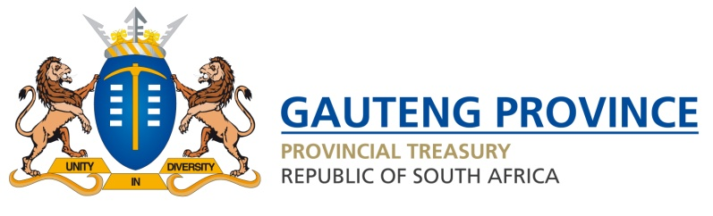

REMARKS BY GAUTENG MEC FOR FINANCE, NOMANTU NKOMO-RALEHOKO, ON THE OCCASION TO PRESENT THE SECOND ADJUSTMENT BUDGET, GAUTENG PROVINCIAL LEGISLATURE, 15 MARCH 2022.

Madam Speaker.

On 09 December 2021, I tabled an adjustments appropriation amounting to R149.5 billion. Subsequent to that adjustments appropriation, the National Departments of Transport and of Human Settlements, in consultation with the National Treasury and affected provincial departments, decreased conditional grants to the Gauteng Province by R71.8 million.

The conditional grants for which the allocation to the Gauteng Province was decreased, are the Provincial Road Maintenance Grant. As a result, the budget for the Gauteng Province for 2021/22 decreases by R71.8 million in the Second Adjustments Budget we are tabling today from R149.5 billion to R149.4 billion.

The adjustments affect the budgets of the Gauteng Department of Roads and Transport, and Gauteng Department of Human Settlements as follows:

- Gauteng Department of Roads and Transport

The 2021/22 adjusted budget of the Gauteng Department of Transport decreases by R51.8 million from R8.5 billion to R8.5 billion. The National Department of Transport decreased the Provincial Road Maintenance Conditional Grant to the Gauteng Province by R51.8 million. The poor spending on the conditional grant was mainly due to department’s inability to finalise procurement of the contractors for maintenance programme on time.

- Gauteng Department of Human Settlements

The 2021/22 adjusted budget of the Gauteng Department of Human Settlements decreases by R20 million from R5.9 billion to R5.9 billion. The National Department of Human Settlement decreased the Informal Settlement Upgrading Partnership Grant. There had to be a lot of planning done for the Informal Settlement Upgrading Partnership Gran from its inception hence the delays that were further exacerbated by prolonged supply chain processes which resulted in delayed appointment of service providers.

Thank You

